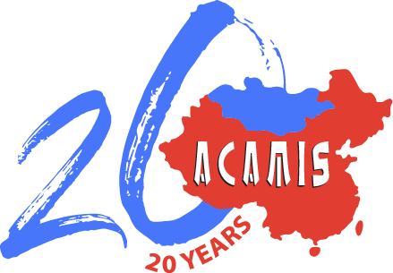

**ACAMIS SERVICE LEARNING GRANT**

**APPLICATION FORM**

To the applicant:Individuals / Group members must complete each of the following sections using the accompanying criteria as a guide. You may wish to attach additional information in support of your project. However, the grant application must not exceed 750 words.

Applying for Service Learning Grant for School Year:

Name of School:

Name of individual / student representative submitting application form:

Email address of individual /student representative submitting application form:

Name of Service Learning Coordinator / Teacher supervising service project:

Email address of Service Learning Coordinator / Teacher supervising service project:

**HEAD OF SCHOOL DECLARATION**

I understand and approve of the project being submitted for the ACAMIS Service Learning Grant:

Head of School Name

Head of School Signature

Date

**Title of the Project:**

|  |
| --- |
|  |

**Basic Description of the Project:**

|  |
| --- |
|  |

**Preparation and Planning:**

|  |
| --- |
|  |

**Action:**

|  |
| --- |
|  |

**Reflection:**

|  |
| --- |
|  |

**Demonstration:**

|  |
| --- |
|  |

**Estimated amount of Grant needed to support the project and indicated the use of the Grant:**

|  |
| --- |
|  |

---------------------------------------------------------------------------------------------------------------------

**FOR ACAMIS USE ONLY**

Grant Status: Successful / Unsuccessful Award Amount: USD